

**A**

**Mini Project Report On**

**“Railway Reservation System”**

**Submitted By**

Alok Jhajharia (4307)

Aman Gupta (4309)

Ashish Mishra (4317)

Atul Kumar Tiwari (4318)

Under the guidance of

**Prof. Y N Gholap**

**Department of Information Technology**

**ARMY INSTITUTE OF TECHNOLOGY, PUNE**

**SAVITRIBAI PHULE PUNE UNIVERSITY**

**2020-2021**

**ACKNOWLEDGEMENT**

I take this opportunity to express my sincere gratitude to **Prof. Y N Gholap** for his immense support and guidance. Without the help and vision provided by him, this project report would not have achieved its present form. I am indebted to **Prof. (Dr.) Sangeeta Jadhav** (Head of Department, Information Technology) for providing me with all the facilities required for the seminar work.

I would like to thank other staff members of the information technology department who have helped me at various stages in the preparation of this seminar, for which I am thankful to them. Last but not the least I would like to extend my thanks to all my friends for their help, which led to the completion of the report.

**CERTIFICATE**

This is to certify that, **Ashish Mishra (4317)** of class T.E IT; have successfully completed their mini project work on “Railway Reservation System’’ at Army Institute of Technology in the partial fulfillment of the Graduate Degree course in T.E at the department of **Information Technology**, in the academic Year 2020-2021 Semester – I as prescribed by the Savitribai Phule Pune University.

Prof. Y N Gholap Dr. (Mrs.) Sangeeta Jadhav

Guide Head of the Department

(Department of Information Technology)

**INDEX**

**Sr. No Content**   **Page no.**

1. Introduction 5
2. Feasibility Study 6
3. System Analysis and Design 7
4. Coding 12
5. Screenshots 15
6. Conclusion 21

7. References 22

**Chapter 1**

**Introduction**

This project aims at development of an Online Railway Reservation Utility which facilitates the Railway customers to manage their reservations online, and the Railway administrators to modify the backend databases in a User-Friendly manner.

The Customers are required to register on the server for getting access to the database and query result retrieval. Upon registration, each user has an account which is essentially the ‘view level’ for the customer.

The account contains comprehensive information of the user entered during registration and permits the customer to get access to his past reservations, enquire about travel fare and availability of seats, make afresh reservations, update his account details, etc.

The Railway Administrator is the second party in the transactions. The administrator is required to login using a master password, once authenticated as an administrator, one has access and right of modification to all the information stored in the database at the server. This includes the account information of the customers, attributes and statistics of stations, description of the train stoppages and physical description of coaches, all the reservations that have been made, etc. The railway administrator has the right to modify any information stored at the server database.

**Platform and Language**

The anticipated system has been totally developed in two environments with front-end as ‘Java’ and back-end as ‘MYSQL 5.6’. jQuery plugins used in these projects are for validation purpose. The site is platform independent it just requires only a browser capable of running the site.

XAMPP and NetBeans IDE is used for development environment. XAMPP is a free and open source cross-platform web server solution stack package, consisting mainly of the Apache HTTP Server, MySQL database, and interpreters for scripts written in the PHP and Perl programming languages.

**Chapter 2**

**Feasibility Study**

In feasibility study phase we had undergone through various steps which are described as under:

1. Identify the origin of information at different level.
2. Identify the expectation user from of the system.
3. Analyze the drawback of existing system.
4. Checked the responsiveness from various devises (Mobile, Laptop, etc.)

**Chapter 3**

**System Analysis and Design**

System analysis is performed to determine if it is feasible to design information on policies and plans of the organization and on user requirements and to eliminate the weaknesses of the present system.

General requirements are:

* The new system should be cost effective.
* To enhance User/System interface.
* To improve information, qualify and usability.
* To upgrade system’s reliability, availability, flexibility and growth potential.

Object-oriented analysis and design (OOAD) is a software engineering approach that models a system as a group of interacting objects. Each object represents some entity of interest in the system being modeled, and is characterized by its class, its state (data elements), and its behavior.

The conceptual model that results from OOA will typically consist of a set of use cases, one or more UML class diagrams, and a number of interaction diagrams.

**Entity – Relationship Diagram**

Name

DOB

Email

Mobile

Gender

Password

Address

USER

Books Trains Ticket/ Enquiry for trains

admin

Train No.

T.Name

Result

Rate

Train DB

Adds Trains Details

Seat

Booking/ display

Order_id

Train No.

uname

display

No.Seat

From & To

Fare

**Activity Diagram**

Cancel a Ticket

Show no matches

User selects cancel from menu

No matching results

Enter keywords / phrases and ckick on submit

User selects inquiry option from menu

Homepage

Matching result

User selects admin panel

Show matches

And links

Update

Edit

Add

Delete

Onclick displays booking procedure

Perform particular operation

**Use case Diagram**

Database

**Data Flow Diagram**

1

Login

DB

DB

User

User

DB

DB

DB

DB

**Chapter 4**

**Coding**

**Codes to creates Tables :**

--

-- Table structure for table `booking`

--

CREATE TABLE `booking` (

  `uname` varchar(15) NOT NULL,

  `Tnumber` int(11) NOT NULL,

  `class` varchar(2) NOT NULL,

  `doj` date NOT NULL,

  `DOB` date NOT NULL,

  `fromstn` varchar(15) NOT NULL,

  `tostn` varchar(15) NOT NULL,

  `Name` varchar(15) NOT NULL,

  `Age` int(11) NOT NULL,

  `sex` varchar(10) NOT NULL,

  `Status` varchar(20) NOT NULL

) ENGINE=MyISAM DEFAULT CHARSET=latin1;

--

-- Table structure for table `interlist`

--

CREATE TABLE `interlist` (

  `Number` int(6) DEFAULT NULL,

  `st1` varchar(10) DEFAULT NULL,

  `st1arri` varchar(10) DEFAULT NULL,

  `st2` varchar(10) DEFAULT NULL,

  `st2arri` varchar(10) DEFAULT NULL,

  `st3` varchar(10) DEFAULT NULL,

  `st3arri` varchar(10) DEFAULT NULL,

  `st4` varchar(10) DEFAULT NULL,

  `st4arri` varchar(10) DEFAULT NULL,

  `st5` varchar(10) DEFAULT NULL,

  `st5arri` varchar(10) DEFAULT NULL,

  `Ori` varchar(20) NOT NULL,

  `Oriarri` varchar(10) NOT NULL,

  `Dest` varchar(20) NOT NULL,

  `Desarri` varchar(10) NOT NULL,

  `Name` varchar(20) NOT NULL,

  `Mon` varchar(2) NOT NULL,

  `Tue` varchar(2) NOT NULL,

  `Wed` varchar(2) NOT NULL,

  `Thu` varchar(2) NOT NULL,

  `Fri` varchar(2) NOT NULL,

  `Sat` varchar(2) NOT NULL,

  `Sun` varchar(2) NOT NULL

) ENGINE=InnoDB DEFAULT CHARSET=latin1;

--

-- Table structure for table `seats_availability`

--

CREATE TABLE `seats_availability` (

  `Train_No` int(11) NOT NULL,

  `Train_Name` varchar(20) NOT NULL,

  `doj` date NOT NULL,

  `1A` int(11) NOT NULL,

  `2A` int(11) NOT NULL,

  `3A` int(11) NOT NULL,

  `AC` int(11) NOT NULL,

  `CC` int(11) NOT NULL,

  `SL` int(11) NOT NULL

) ENGINE=MyISAM DEFAULT CHARSET=latin1;

--

-- Table structure for table `train_list`

--

CREATE TABLE `train_list` (

  `Number` int(6) NOT NULL,

  `Name` varchar(20) NOT NULL,

  `Origin` varchar(20) NOT NULL,

  `Destination` varchar(20) NOT NULL,

  `Arrival` varchar(10) NOT NULL,

  `Departure` varchar(10) NOT NULL,

  `Mon` varchar(2) NOT NULL,

  `Tue` varchar(2) NOT NULL,

  `Wed` varchar(2) NOT NULL,

  `Thu` varchar(2) NOT NULL,

  `Fri` varchar(2) NOT NULL,

  `Sat` varchar(2) NOT NULL,

  `Sun` varchar(2) NOT NULL,

  `1A` int(11) NOT NULL,

  `2A` int(11) NOT NULL,

  `3A` int(11) NOT NULL,

  `SL` int(11) NOT NULL,

  `General` int(11) NOT NULL,

  `Ladies` int(11) NOT NULL,

  `Tatkal` int(11) NOT NULL

) ENGINE=InnoDB DEFAULT CHARSET=latin1;

--

-- Table structure for table `users`

--

CREATE TABLE `users` (

  `f_name` varchar(50) NOT NULL,

  `l_name` varchar(50) NOT NULL,

  `email` varchar(50) NOT NULL,

  `password` varchar(20) NOT NULL,

  `gender` varchar(10) NOT NULL,

  `marital` varchar(10) NOT NULL,

  `dob` varchar(20) NOT NULL,

  `mobile` bigint(10) NOT NULL,

  `ques` varchar(100) NOT NULL,

  `ans` varchar(100) NOT NULL

) ENGINE=InnoDB DEFAULT CHARSET=latin1;

**Chapter 5**

**Snapshots**

**Computer Screenshots**

**1.Home Page**

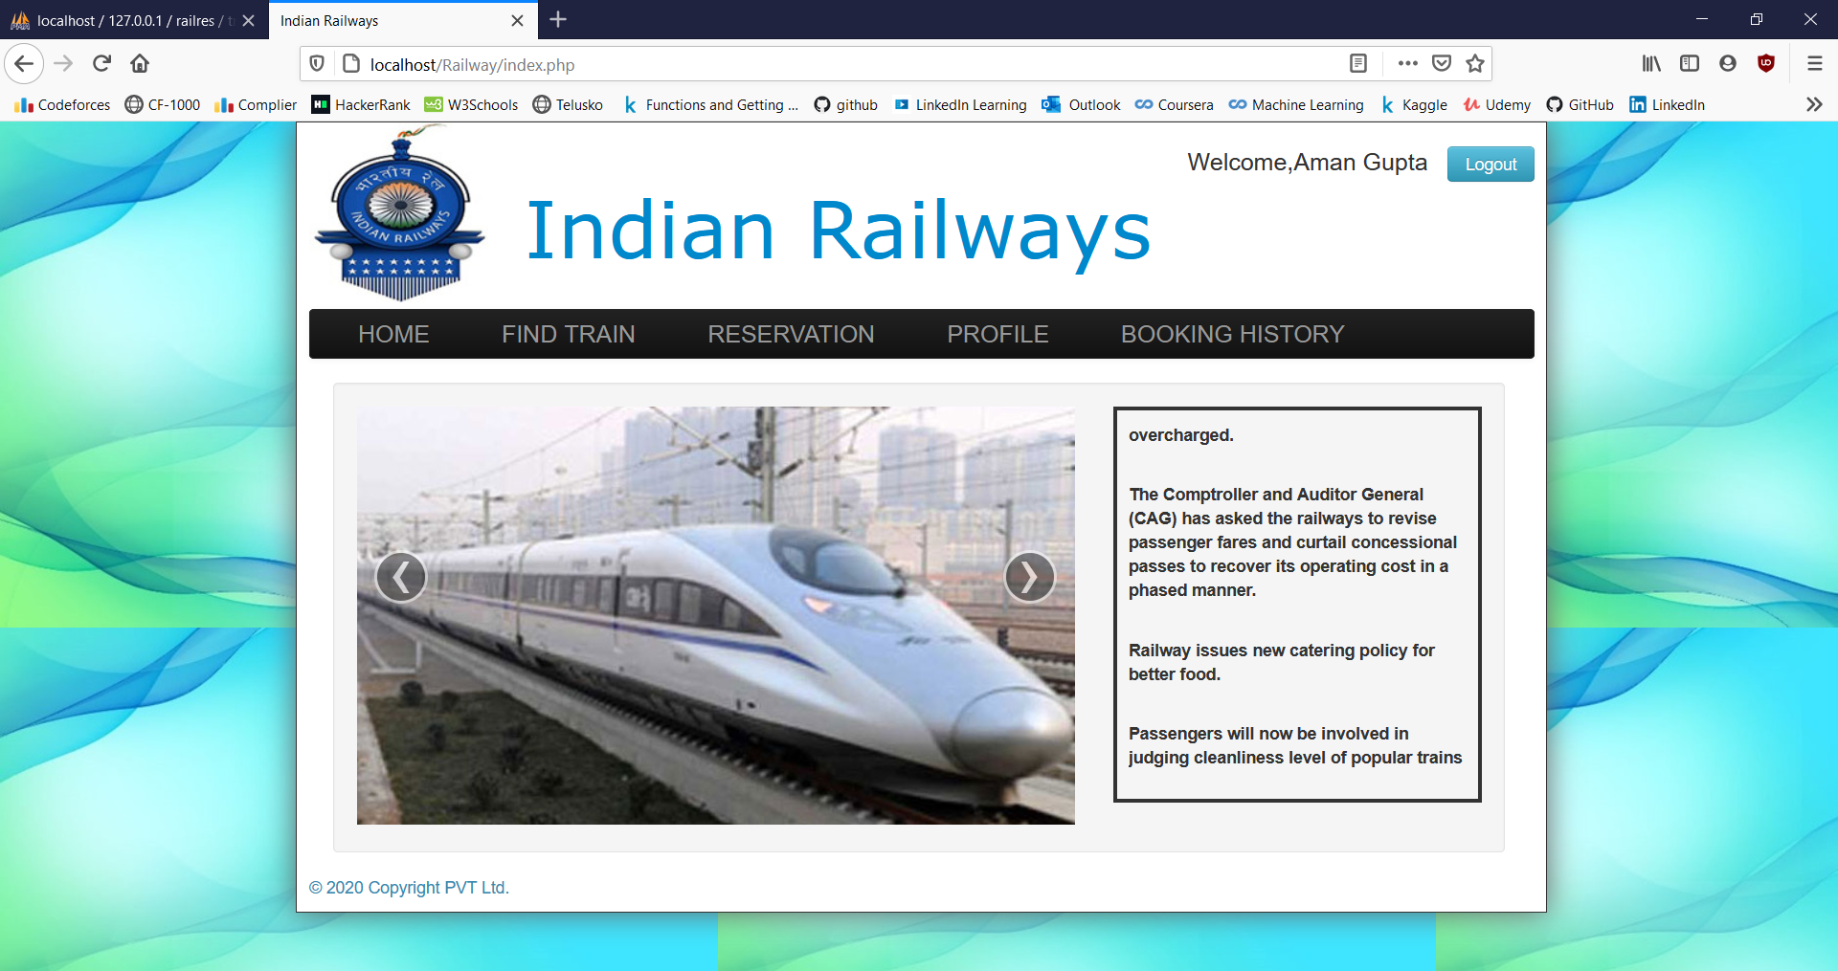

**2. Registration Form**

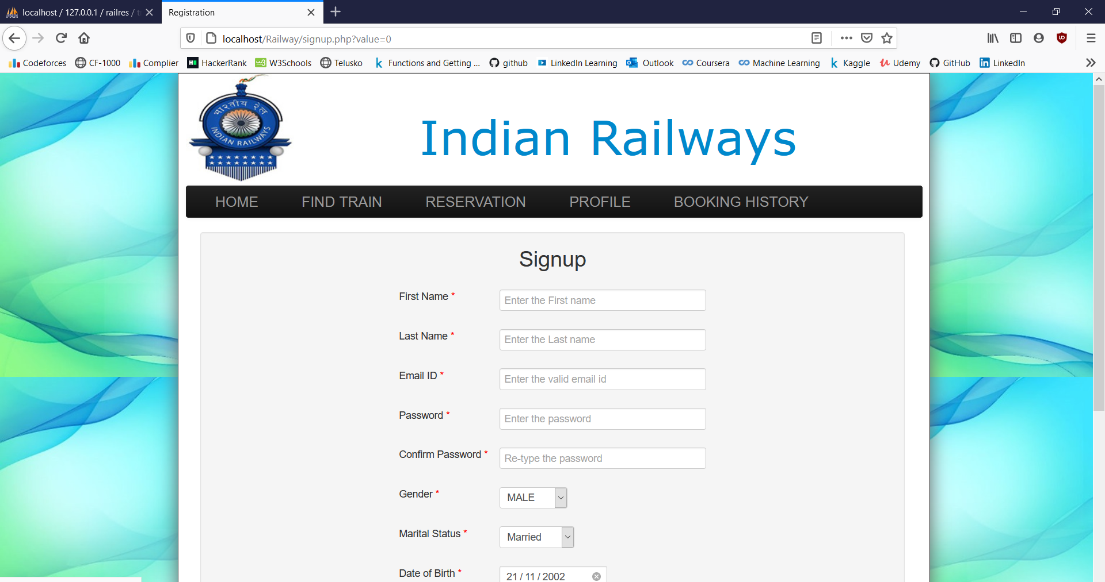

**3. Book Ticket**

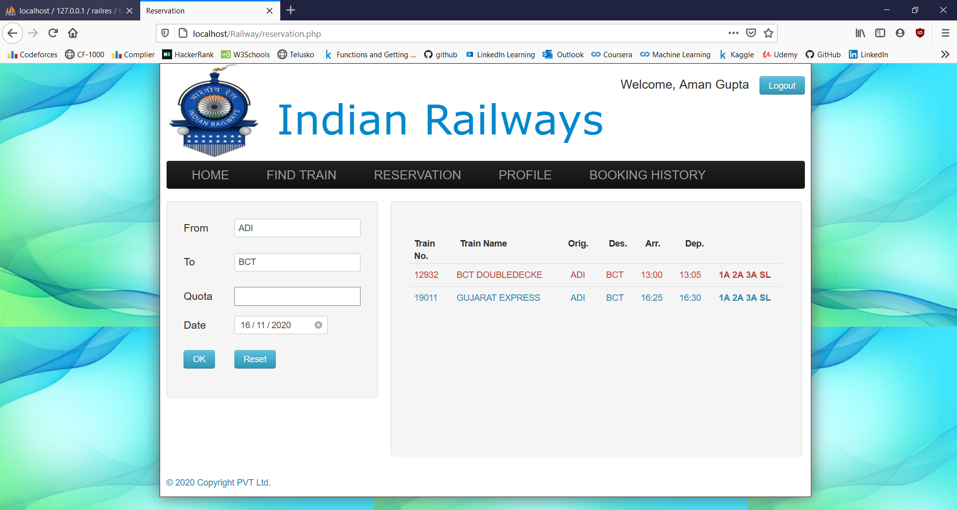

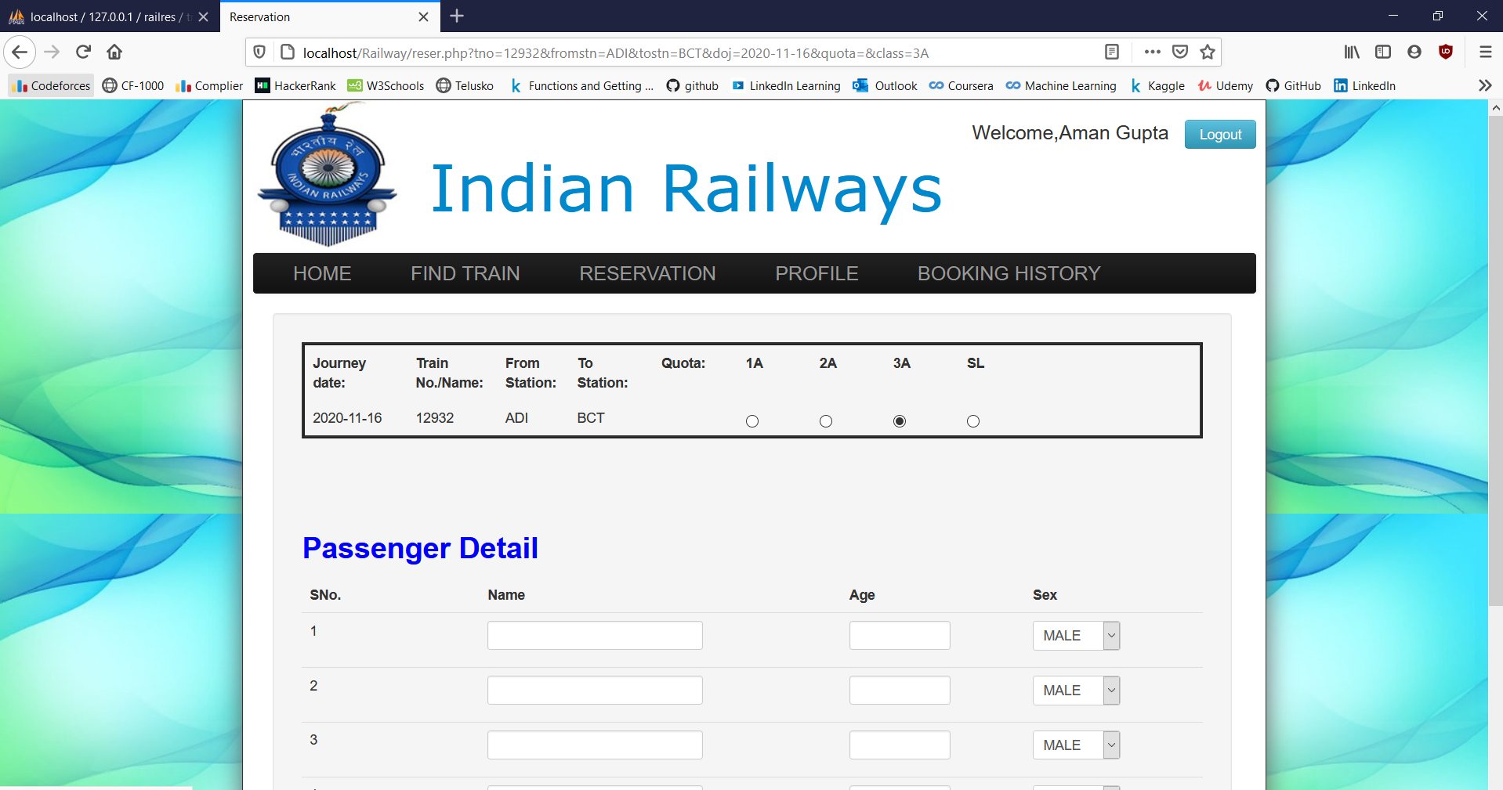

**4. Find Train**

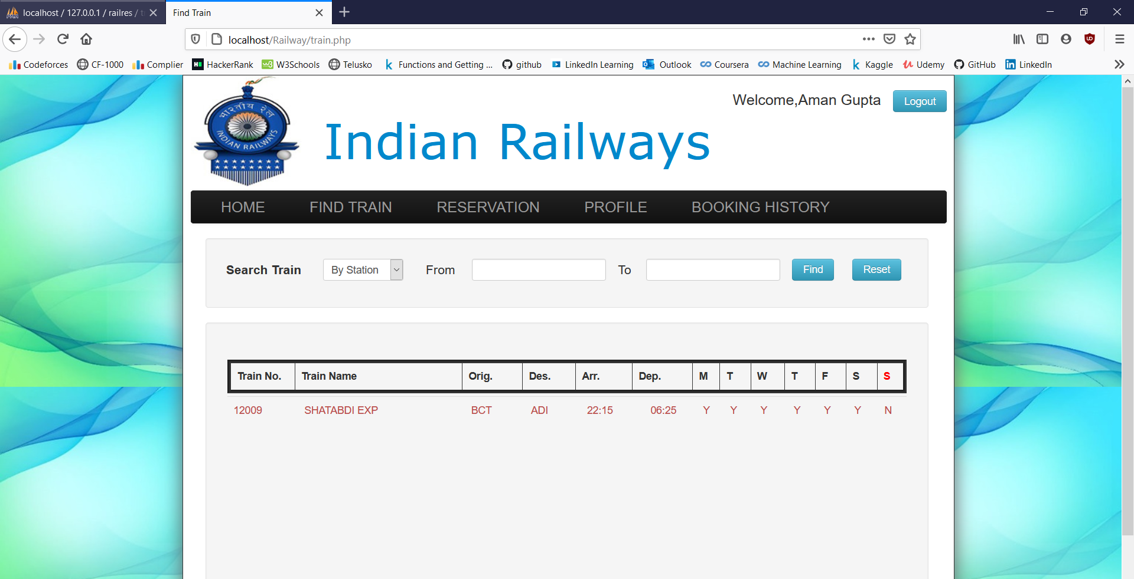

**5. Booking History**

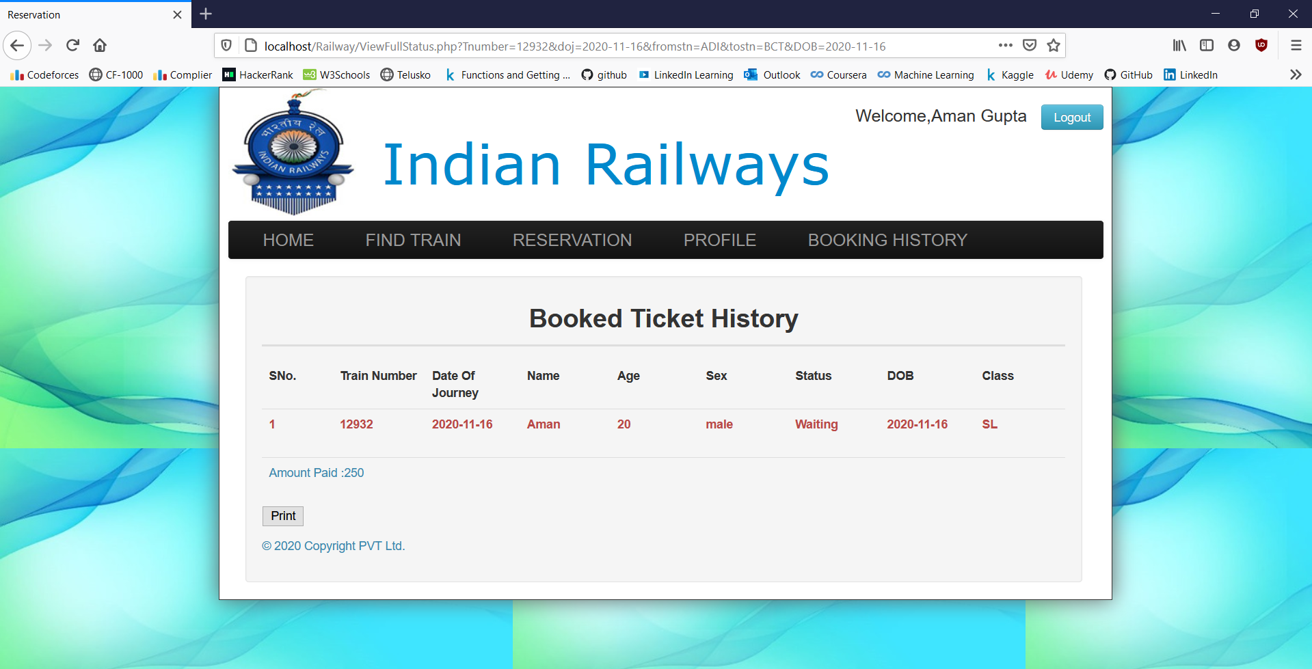

**6. Profile**

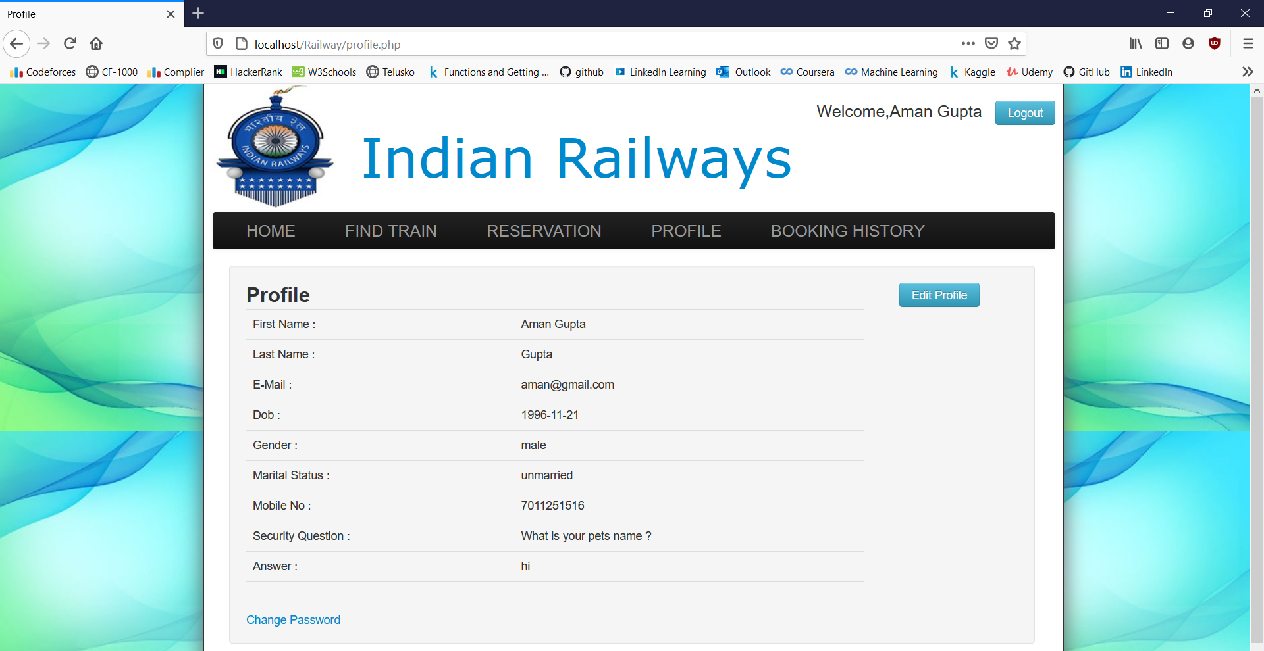

**Database Screenshots**

**1.Booking Table**

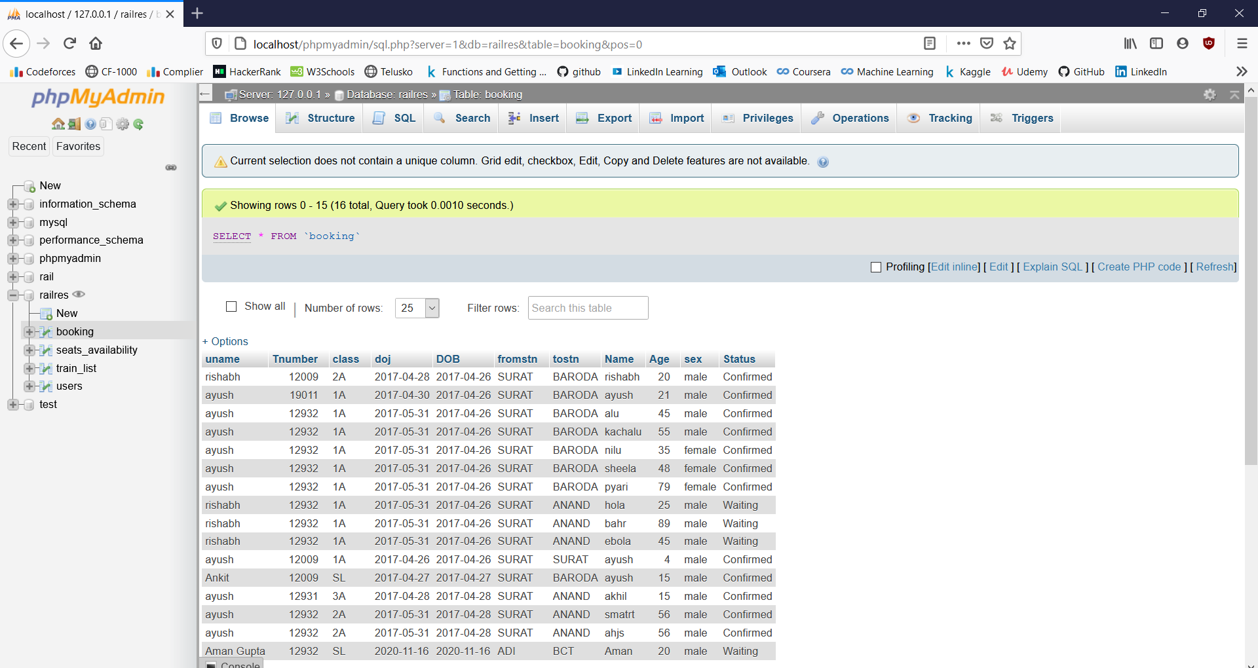

**2.Seat Availability**

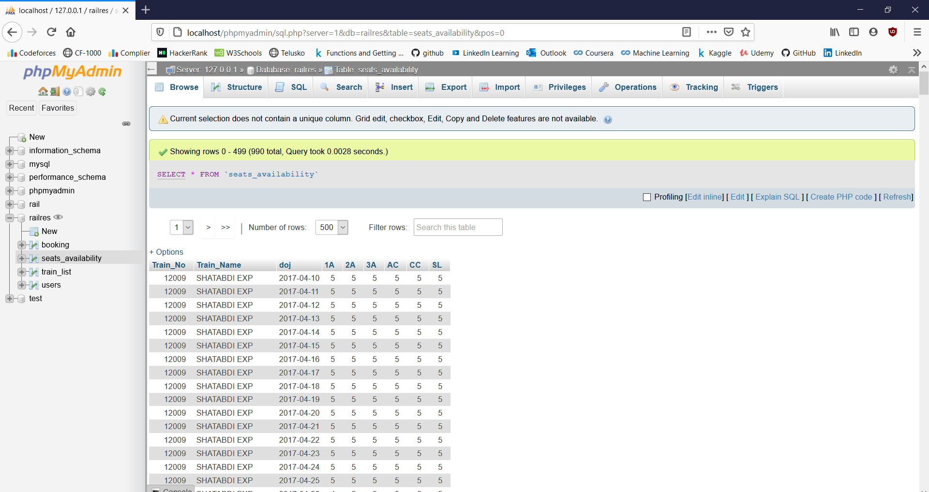

**3.Train List**

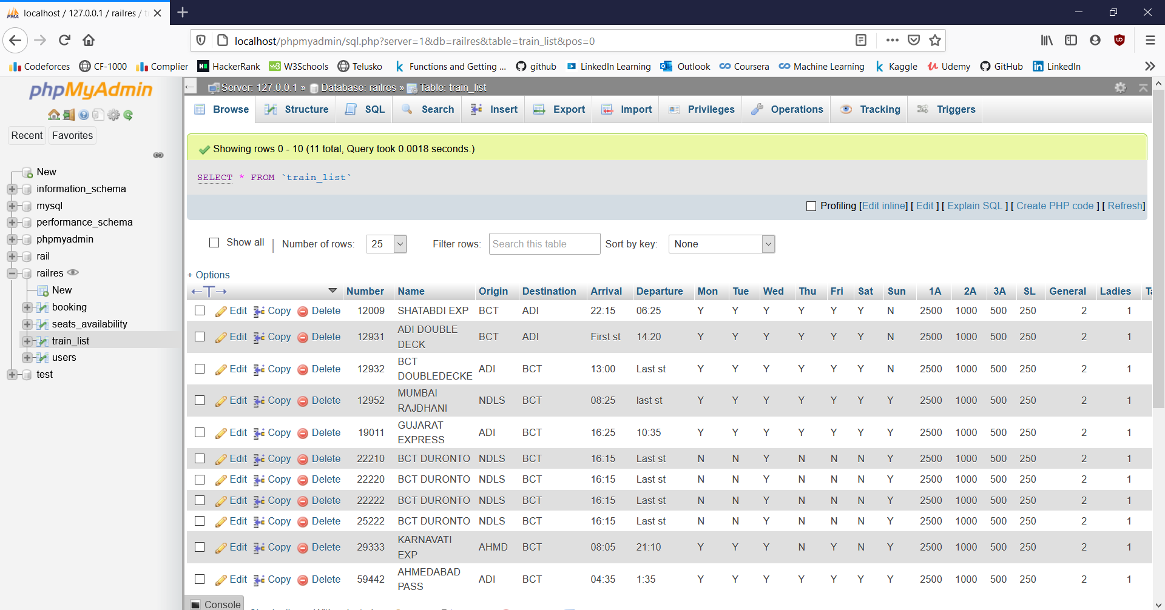

**4.Users**

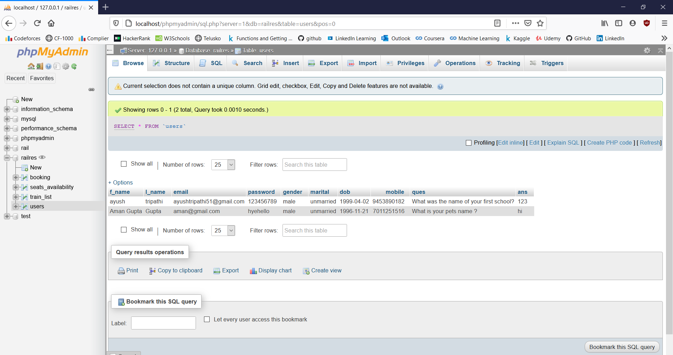

**Chapter 6**

**Conclusion**

We have Successfully implemented “Railway Reservation System” website. We used Java for Front-end and MySQL for Back-end as the main tools to make our website and database, with the help of languages like HTML5, CSS and JavaScript.

XAMMP is used as the platform to make the Database.

The main aim of developing Reservation system is to provide all information that is required by the users. User friendliness is a must that is the user must get the details without complicated searching procedures. Other important requirements of software are data security, extensibility and maintainability. All these features are included in this web application. The project greatly helped in understanding the various phases in website development and exposure to a new developer platform NetBeans, .Net and database MySQL Serve

**References**

1. <http://www.mysqltutorial..org/> : Basics of MySQL.
2. <http://php.net/manual/en/tutorial.php> : Tutorial of php language. Basic explanation of syntaxes of the language.
3. <http://www.w3schools.com/html/> : Basics of HTML, Bootstrap4 tutorials and JavaScript.
4. <http://www.apachefriends.org/index.html/> : To download and see the functioning of Xampp.
5. Referenced for Java and MySQL tutorial :[www.newboston.org](http://www.newboston.org/)
6. Referenced for the data source : [www.wikipedia.com](http://www.wikipedia.com) .

Books:

1. Java Advanced, Third Edition, published by Pearson Education, Inc, 2013.
2. MySQL, first edition, by Larry Ullman, published by Pearson Education, Inc, 2011.